Project 1: Exploratory Data Analysis of the ANSUR Anthropometric Measure Dataset

Rebecca Yoo
March 3, 2026
PBHLT 6101 Data Management And Visualization

Introduction
This report summarizes anthropometric data from the ANSUR II Working Database produced by the US Department of the Army. The anthropometric data is used by the US Army to design clothing, personal protective equipment, military workstations, and computer-generated models of the body.
The purpose of this analysis is to provide a summary of anthropometric characteristics of military personnel and the relationships between them. The results of this analysis would then be usable for designing materials and equipment for military use. The analysis is achieved by conducting Exploratory Data Analysis (EDA) on anthropometric measurements and demographic characteristics of individuals in the military.
The sample was generated by the US Department of the Army through two sampling efforts: the ANSUR II and MC-ANSUR. These efforts collected the data following a protocol documented in Measurer’s Handbook: US Army And Marine Corps Anthropometric Surveys, 2010-2011.
The dataset includes 7,031 observations. Two types of variables are included in the dataset: socio-demographic variables and anthropometric variables. While the full dataset provided by the US Department of the Army includes 94 anthropometric variables, the scope of this report analyzes 17 select anthropometric variables.

Data preparation
Data preparation included the following steps:
- finding, correcting and documenting data problems and errors;
- recoding data and creating new variables; and
- providing documentation that the coding is correct.
Specific steps of the data preparation included the following:
- Changing missing values to STATA special missing values
- Inspecting, identifying, and organizing suspicious values
- Identifying and organizing duplicate observations
- Label all variables and values of categorical variables
- Removing information of minors
- Converting units
The following new variables were created:
- A unique key variable
- A continuous BMI variable
- A categorical BMI variable
- A variable that indicates the season the measurements were made
- A numerical variable for each of gender and preferred hand. (use encode)
- A variable that indicates a body type
A data analysis plan is shown in Table 2-1.
Table 2-1: Data Analysis Plan
Step | Detailed steps
Organize files | - Download all files from data source (Canvas)  - Make a copy of the raw dataset file
Explore resources | - Read task instructions (assignment). Review the table of variables provided in the instructions.  - Memo For Record PDF: read overall description of the data; see short list of measurements  - Measurer’s Handbook PDF: locate measurement methods on page 73; see Appendix H
Prepare files | - Open .dta file  - Create new .do file  - Annotate .do file with headers (name, date, project info)  - Create word doc for the project deliverable.  - Organize with headers and bookmarks.  - Write introduction
Browse data | - Open data browser and skim dataset  - Look at variables in instruction doc and compare with variables in .dta file
Clean data | - Create unique observation id variable  - Before cleaning data, use gen to give each observation a unique obs_id value so that changes can be tracked while cleaning data  - Use data browser to check work.  - Missing values: Replace negative values with STATA special missing values  - Use replace to replace negative values with STATA special missing values  - Nest the replace command in a loop using foreach to replace missing values for all variables  - Annotate special missing values  - Check work using misstable. Annotate. Save.  - Suspect/unreasonable values: Inspect. Create new binary variable to indicate unreasonable values  - Inspect all variables for incorrect, invalid, or suspect values. Use codebook , hbox (boxplots) and summ to inspect variables.  - Make reasonable corrections or change to special missing values. Create indicator variables with a code of 1 for suspect/unreasonable values and 0 for reasonable values.  - Check work using list and twoway. Annotate. Save.  - Duplicates  - Find exact duplicates and move to a separate dataset. Use duplicates  - For suspect duplicates, create a new binary variable  - Check work. Annotate. Save.  - Remove irrelevant data: <18 yo  - Inspect how many minors there might be using tab and if  - Use a loop with an if statement for minors to replace all values with missing values except for the unique observation ID and age.  - Create two loops: one for numeric variables and one for string variables using if to identify variables with numeric vs string variables  - For numeric variables: replace values with “.”  - For string variables: replace values with “”  - Check work using list with if statement for minors. Annotate. Save.  - Convert variables in mm to cm  - Inspect variables that are in mm using summ  - Create a loop that creates new variables ending in _cm that converts mm to cm  - Check work using summ. Annotate. Save.
Label | - Label all variables and values of categorical variables. Use label  - Use PDF documents to find appropriate labels. Label those variables.  - Create labels for all other variables.  - Label categorical variables.  - Check work using variables panel. Annotate. Save.
Create new variables | - Observation ID: This was moved to the cleaning step.  - Continuous BMI and BMI_cat  - Find equation for calculating BMI  - Gen bmi variable and calculate using weight and height. Ensure the units are converted appropriately.  - Find BMI categories online  - Gen bmi category variable using if statements  - Check work using tabstat. Annotate. Save.  - Season  - Find a source that defines seasons by months.  - Gen a season variable and use replace with if statement to define values of season depending on the month.  - Check work using tab. Annotate. Save.  - Gender and preferred hand (numerical)  - Inspect data using levelsof to see categorical variables  - Clean typos using replace  - Use encode to create new numeric values for gender and hand  - Check work using tab. Annotate. Save.  - Body type  - Research body types and important anthropometric measures that are used in designing clothes  - Choose a concept and document it. In my case, I chose to use the waist and hip measurements, as well as BMI.  - Gen new variables to use, including for body categories and waist-to-hip ratio.  - Use replace and if statements to define the body categories.  - Check work using tab. Annotate. Save.
Anthropometric characteristics | - Summarize anthropometric measures: include variable name, description, stats, number of missing values, and number of suspicious values  - Use summ and tabstat to create a list of variables  - Use a loop to define suspicious values. Define suspicious values as outliers on a boxplot  - Use misstable to find missing variables  - Copy data into excel spreadsheet, organize it by body part, and copy it onto word document  - Check work using summ and misstable. Annotate. Save.  - Create figure showing differences in % of total height (height to hip by sex)  - Gen a variable that divides hip over stature for the proportion  - Use graph, bysort, summ to produce a figure and analyze the proportion by sex  - Check work by viewing the figure and see if it makes sense. Annotate. Save.  - Copy figure into report  - Write a description
Relationships | - Relationship between measures of stature  - Identify 2 variables with highest correlation. Use pwcorr to find the variables with the highest correlation coefficient absolute value.  - Use a scatterplot and regression line to show the relationship.  - Check my work by doublechecking correlation coefficient values. Annotate. Save.  - Copy the figure into the report.  - Write description paragraph.  - Assess the level of correlation between overall height (stature) and the other measures of stature, stratified by sex  - Use bysort and pwcorr  - Assess correlation coefficients  - Copy the output into an excel sheet. Organize data by males and females.  - Check my work by doublechecking correlation coefficient values. Annotate. Save.  - Copy table into report.  - Write description paragraph.  - Relationship between actual and reported height and weight  - Create variables for measured and reported height and weight  - Use histogram graph and sum to understand the variables  - Check my work by assessing the figures. Annotate. Save.  - Copy figure into report.  - Write description paragraph.  - Reported and measured differences compared across sex: weight  - Use graph sum and histogram to view the differences  - Adjust the data and outliers to see how the range and understandability of the analysis changes  - Produce a boxplot and import to report  - Check my work. Annotate. Save.  - Comparison between reported and measured height  - Use graph sum and histogram to view the differences  - Adjust the data and outliers to see how the range and understandability of the analysis changes  - Produce a boxplot and import to report  - Check my work. Annotate. Save.  - Relationship derived 'body type' and weight/BMI  - Use heatplot, once for each sex, to show how weight and BMI are distributed across the different body types  - Copy the figure into the report  - Check work. Annotate. Save.  - Write description paragraph
Review | - Check variable labels  - Check unreasonable values  - Report  - Review content  - Format
Appendix | - Copy in stata code  - Save word doc.
Upload project | - Upload do Canvas

3. Sample characteristics

3.1 Anthropometric characteristics
Table 3.1-1 shows summary statistics for the anthropometric values in the dataset.

Table 3.1-1: Anthropometric characteristics
Description | Variable | Observations | Mean | SD | Min | Max | Missing Values (n) | Suspicious values (n)
measured weight, kg | weightkg | 7,028 | 80.0 | 15.6 | 35.8 | 144.2 | 0 | 84
bicristal breadth, cm | bicristalbreadth_cm | 7,028 | 27.5 | 1.9 | 19.7 | 36.2 | 0 | 19
chest cirumference, cm | chestcircumference_cm | 7,028 | 102.5 | 10.0 | 69.5 | 146.9 | 3 | 0
hip breadth, sitting, cm | hipbreadthsitting_cm | 7,028 | 38.6 | 3.2 | 28.0 | 54.1 | 0 | 23
hip breadth, cm | hipbreadth_cm | 7,028 | 34.8 | 2.5 | 26.4 | 47.3 | 3 | 0
waist cirumference, cm | waistcircumference_cm | 7,028 | 91.7 | 11.4 | 61.1 | 137.9 | 0 | 90
height to neck cervical, cm | cervicaleheight_cm | 7,028 | 148.0 | 8.4 | 118.4 | 173.8 | 0 | 89
ball of foot length, cm | footlength_cm | 7,028 | 26.3 | 1.7 | 19.8 | 32.3 | 0 | 3
functional leg length, cm | functionalleglength_cm | 7,028 | 110.4 | 6.8 | 83.5 | 131.6 | 3 | 0
knee height, midpatella, cm | kneeheightmidpatella_cm | 7,028 | 47.5 | 3.3 | 34.6 | 61.2 | 0 | 3
span, cm | span_cm | 7,028 | 176.8 | 11.0 | 132.3 | 212.1 | 3 | 0
measured height, cm | stature_cm | 7,028 | 171.7 | 9.0 | 140.9 | 199.3 | 0 | 3
thumbtip reach, cm | thumbtipreach_cm | 7,028 | 80.3 | 28.3 | 60.2 | 934.0 | 0 | 35
height to hip, cm | trochanterionheight_cm | 7,028 | 88.3 | 5.4 | 66.0 | 109.5 | 3 | 0
waist height, cm | waistheightomphalion_cm | 7,028 | 103.3 | 6.3 | 80.5 | 124.5 | 3 | 0
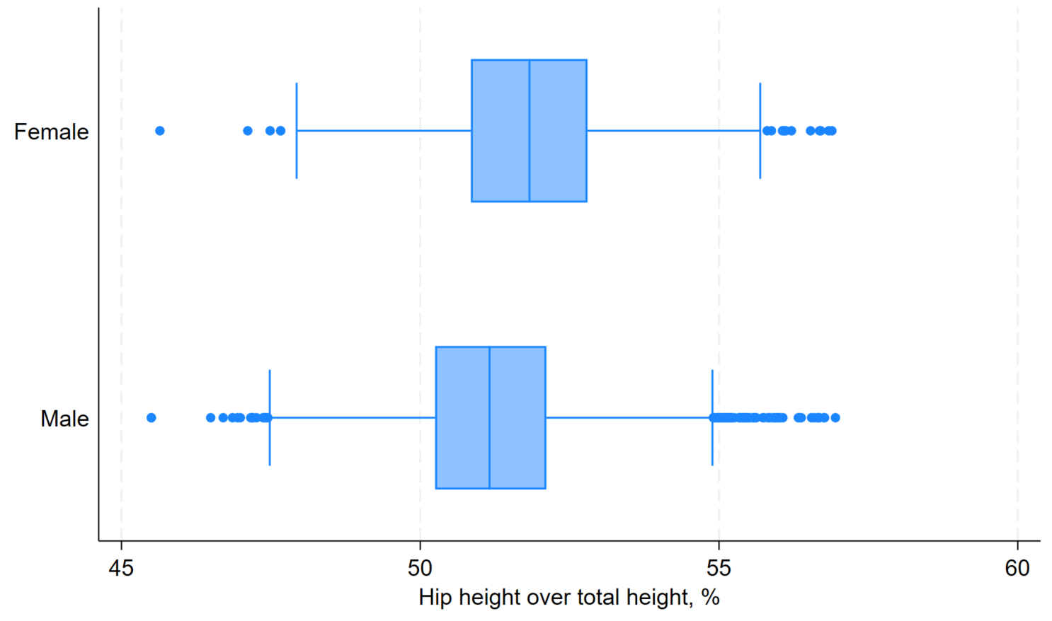
Figure 3.1-1: Percent of total height attributable to the height to hip by sex
The percent of total height attributable to the hip height describes, roughly, the proportional height of the lower body to the total height. In plain terms, individuals with longer legs are expected to have a higher percent than individuals with shorter legs. In the figure, we observe females having a higher percent than males, indicating that females have proportionally taller lower bodies than males. The median percentage for females and males is 51.8% and 51.2%, respectively. The median proportional height of the lower body to the full height is 0.6% higher in females than for males in the sample group.

3.2 Data quality assessment
As described in Section 2, the dataset contained missing values, suspicious values, values that are not publishable, and values with inconsistent units. Missing values were found by assessing missing value coding and were recoded to be uniform. Suspicious values were found by summarizing data and assessing obvious outliers. These obvious outliers were recoded to missing values. In addition to obvious outliers, the dataset included outliers that deemed review. These outliers were coded with a separate variable, rather than deleted, so that they could be viewed with caution. The outliers were defined as values outside 1.5 times the IQR, as defined in a typical box-and-whisker plot. The dataset included data about minors, or people under the age of 18. The data for these observations were deleted, except for the Observation ID and age in order document that data existed although it is no longer shown. Values with inconsistent units were provided with new variables that shows consistent measurement units. The original variables were not changed. This allows consistency across iterations of analyses while also allowing accurate calculations on the anthropometric values.

4. Relationships between anthropometric measures.

4.1 Relationship between measures of stature
The level of correlation between the measures of stature were assessed. The correlation coefficients for measures of stature variables range between 0.15 and 0.94 and every p-value is less than 0.0001. The two variables with the highest correlation coefficient are waistheightomphalion and cervicaleheight. When fit with a linear regression, the regression shows that for every unit increase of waistheightomphalion, there is a 1.26 unit increase in cervicaleheight. Although both variables are provided in units of mm, the relationship is consistent in inches, also. In other words, for every inch increase of height to the hip, there is 1.26 inches of increase height to the neck cervical. The R-squared value is 0.8852 for the linear regression.
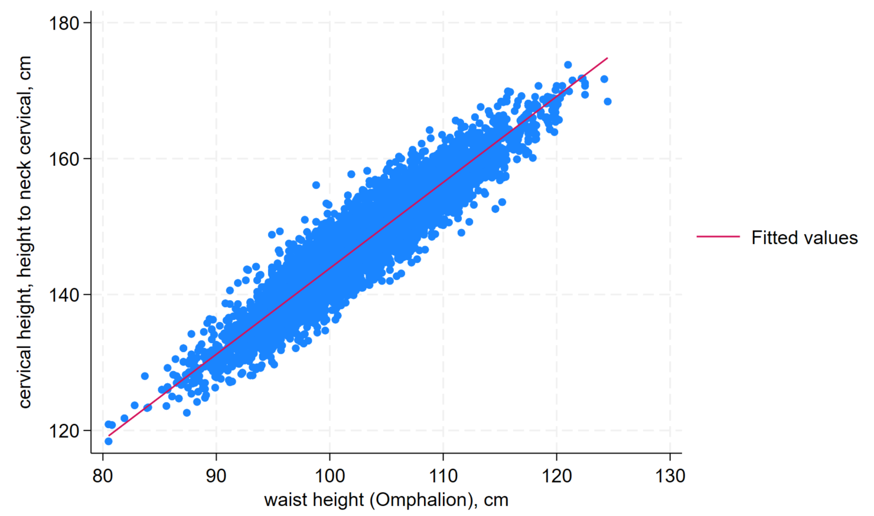
Figure 4.1-1 Cervical height vs waist height
The variables with the three highest correlation coefficients and the two lowest correlation coefficients are the same for both males and females. The variables with the highest correlation coefficients (reported in parenthesis as female and male, respectively) are height to neck cervical (0.9845, 0.9840), waist height (0.9097, 0.9074), and height to hip(0.8586, 0.8527). The two variables with the lowest correlation coefficients are forward arm reach and foot length. The variable with the third lowest correlation coefficient is arm span for females and functional leg length for males. The correlation coefficient is consistently higher for females than males except for arm span, which has a correlation coefficient that is 0.24 higher for males than that of females.

Table 4.1-1 Relationship between height and other anthropometric measures
Description | Variable Name | Correlation Coefficient
 |  | Female | Male
height to neck cervical | cervicaleheight | 0.9845 | 0.9840
waist height | waistheightomphalion | 0.9097 | 0.9074
height to hip | trochanterionheight | 0.8586 | 0.8527
knee height | kneeheightmidpatella | 0.8406 | 0.8335
functional leg length | functionalleglength | 0.8316 | 0.8123
arm span | span | 0.8202 | 0.8226
foot length | footlength | 0.7251 | 0.7169
forward arm reach | thumbtipreach | 0.1402 | 0.1147

4.2 Relationship between actual and reported height and weight
The difference in measured and reported height was assessed. The difference was calculated as the measured weight (weightkg) minus the reported weight (weightlbs). The interquartile range of the difference is from -2.39 to 3.66 with the median at 0.52, showing that typically, the reported weight is lower than the measured weight by 0.52 lbs. The 10th and 90th percentiles are -5.6 and 7.4, respectively, while the range is -145.8 to 194.4. This shows that most weight differences are reasonable and there were some outliers that are obviously incorrect.

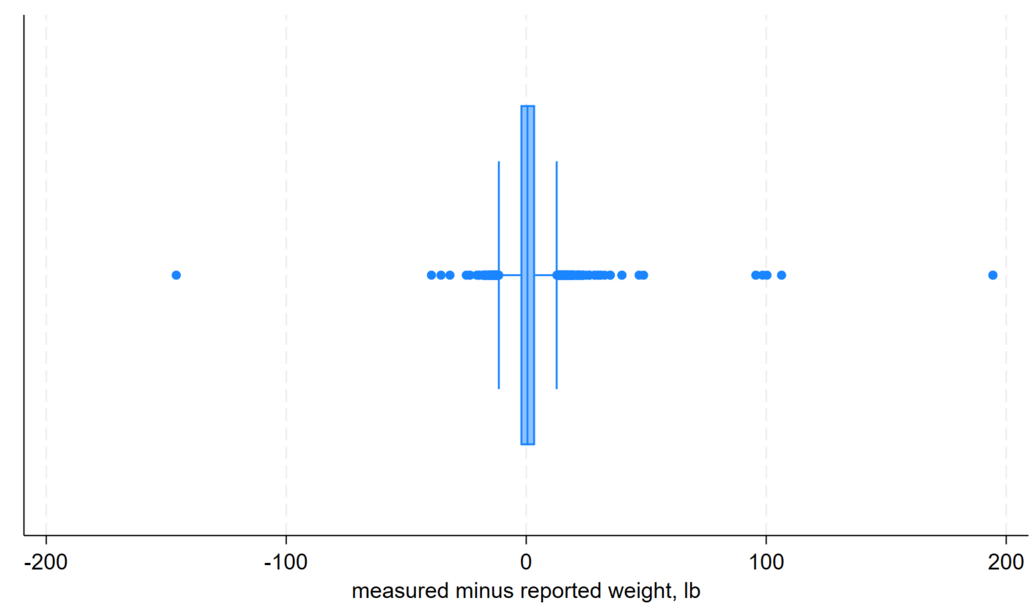
Figure 4.2-2: Difference between measured and reported weight
While Figure 4.2-2 shows the spread of the data, Figure 4.2-3 is helpful in assessing the central values that contain the majority of the observations. Figure 4.2-3 shows the distribution of difference observations when the range is limited to a weight difference of 10 lbs.
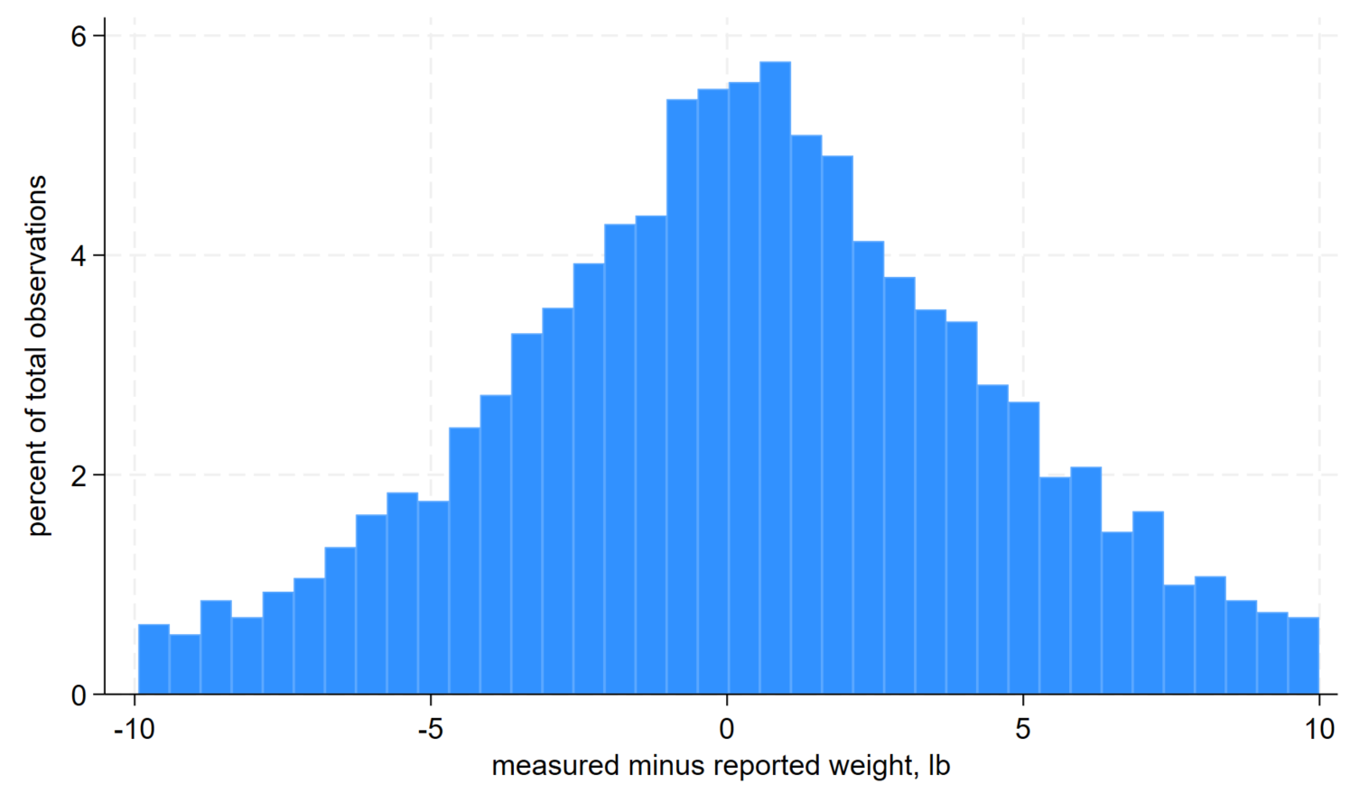
Figure 4.2-3: Distribution of difference between measured and reported weight between -10 lb and 10 lb
Next, the extent to which the difference between reported and measured weight varies by sex was assessed. When all values are included, the female IQR is -1.2 to 4.1 with median at 1.2. For males, IQR is -3.0 to 3.3 with median at 0.1. This shows that males generally had a larger range of differences but females overall had more of a difference in measured versus reported weight. To observe reasonable values only, the range was again limited to a weight difference of 10 lbs. The differences are shown below in Figure 4.2-4.

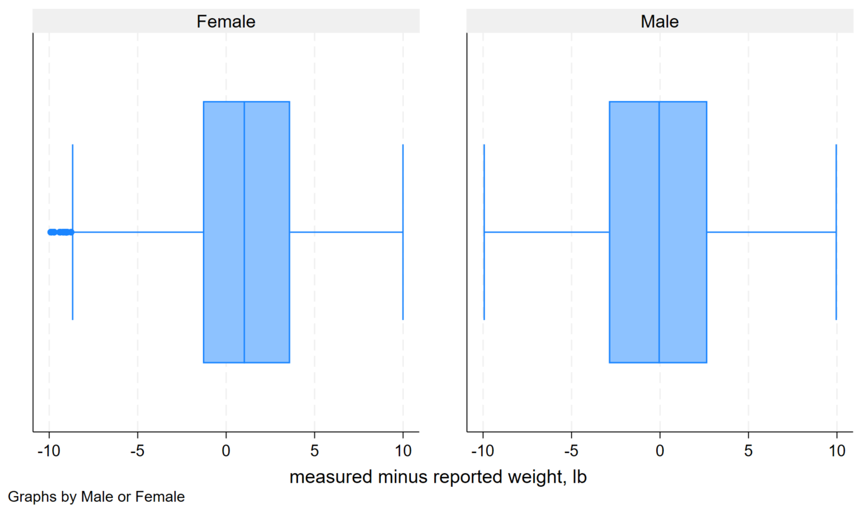
Figure 4.2-4: Difference between reported and measured weight, by sex
The self-reported height to the measured height was compared next.
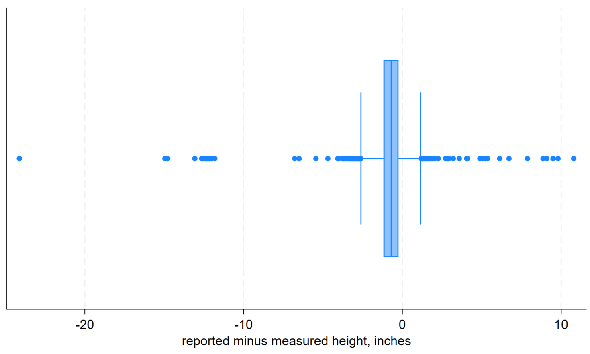
Figure 4.2-5: Difference in reported versus measured height
The distribution of the difference is a tall and narrow normal curve, showing that most heights are generally precise within a certain range. The IQR ranges from -1.2 to -0.24, showing that the measured height is usually up to 1 inch higher than the reported height. The 10th and 90th percentiles are -1.7 and -0.2, respectively, while the range is from -24.1 to 10.8.
The reported and measured height and weight values showed significant differences in some observations, while most were within an acceptable range for designing clothes. If the outliers were to be used in calculating overall anthropometric summaries, the bias would skew the measurements significantly due to the spread of the outliers. However, the outliers are easy to assess and if dealt with, using values within the IQR would provide reasonable values for designing clothes and equipment.

4.3 Relationship derived ‘body type’ and weight/BMI
The distributions of weight and BMI for each of the body types are compared in the figures below. The figures show that the most observations were seen in the medium box, followed by heavy triangle and light hourglass among females. For males, most observations were categorized as light hourglass, followed by medium hourglass and medium box. The body types captured the spread of different BMI and weight among the two sexes efficiently. Each body type contained observations, showing that the categories were spread apart enough to capture all observations while also providing information to efficiently design clothes and equipment since the heatplots show the density of observations.
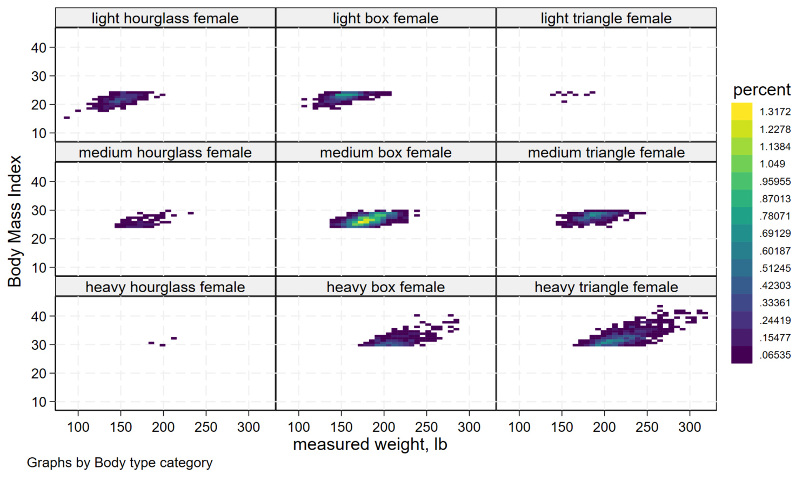
Figure 4.3-1: BMI and weight distribution across female body types

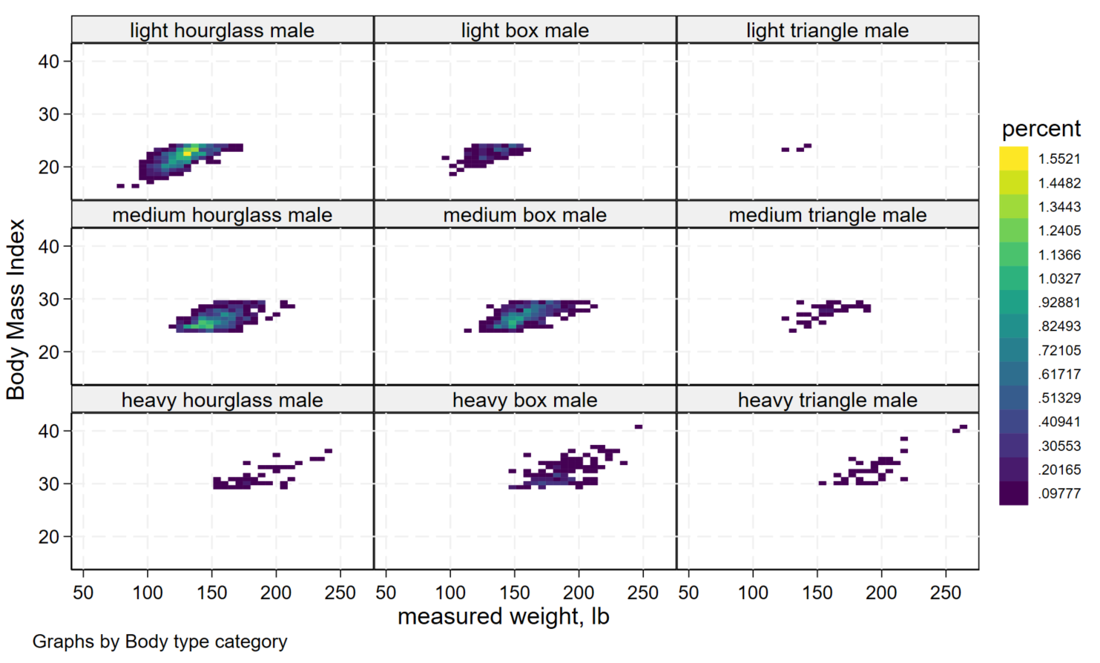
Figure 4.3-2: BMI and weight distribution across male body types

Appendix.
*Title: PBHLT 6101 PROJECT 1 - ARMY ANTHROPOMETRIC DATA ANALYSIS
*Author: Rebecca Yoo
*Date: 2026-02-16
*Stata Version:BE 19.5
*File Version: 1

clear
*Save working directory
cd "C:\Users\Rebecca\OneDrive - University of Utah\1_Data\4_Projects"
*Open dataset
use "C:\Users\Rebecca\OneDrive - University of Utah\1_Data\4_Projects\ansur2allV2.dta"

**********STEP 2: DATA PREPARATION**********

*CREATE OBSERVATION ID
gen obs_id = _n

*MISSING VALUES
*Identify variables with missing values by looking at the range
codebook
*These variables have missing values: thumbtipreach span footlength kneeheightmidpatella waistheightomphalion functionalleglength cervicaleheight trochanterionheight stature waistcircumference chestcircumference bicristalbreadth hipbreadth weightkg
*Codebook showed me the range, so I can see the minimum values, ie -99, but I want to see all the negative values of each variable. Use a loop to look at all variables. Limit to looking at only numeric variables to avoid an error on "<0".
ds, has(type numeric)
foreach var of varlist `r(varlist)'{
tab `var' if `var'<0
}
*It seems like -99 is the only negative value out of all the variables. -77 and -88 aren't recorded anywhere.
*Nevertheless, create code to change all missing values to State missing values so that the code is useful regardless of the dataset.
* New codebook:
* -77 not recorded --> .a
* -88 refused measurement --> .b
* -99 unknown missing --> .c
mvdecode _all, mv(-77 = .a \ -88 = .b \ -99 = .c)
*Check my work. Note that the tab function's default is to show non-missing values only, which is why we need to choose the missing option to tell it to show missing values.
ds, has(type numeric)
foreach var of varlist `r(varlist)'{
tab `var' if `var'>=., missing
}
*Check my work
misstable summ

*UNREASONABLE VALUES
**Look for unreasonable values using codebook
codebook
*Looks like only weight variables are unreasonable. Create new binary variable for each of the weight variables and code 1 if unreasonable.
*
*
*
*Look at weightkg (Measured weight)
*weightkg_sus for suspicious weightkg values
*Look at boxplot and summ of weightkg to look at range
graph hbox weightkg
gen weightkg_sus = 0
replace weightkg_sus = 1 if weightkg>500
*It seems there are weights that are 10 times larger than they should be. Those values are above 500 kg. I'll replace those suspicious values with the weight divided by 10, which is more realistic
replace weightkg = weightkg/10 if weightkg_sus==1
*Check what the weights look like now.
graph hbox weightkg
*Looks much better
*
*New codebook: weightkg_sus code
*** 1 if unreasonable bc weight was higher than 500; replaced weightkg value with weightkg divided by 10
*** 0 if reasonable
*
graph hbox weightkg
*Confirm that the fixed weightkg looks similar to the self-reported value weightlbs
**Create a new var with measured weight in lbs
gen weightkg_to_lb = weightkg * 2.20462
**Calculate difference in measured and reported weight
gen weight_diff = weightkg_to_lb - weightlbs
levelsof gender
histogram weight_diff if weightkg_sus==1 & gender=="Female", frequency
histogram weight_diff if weightkg_sus==1 & gender=="Male", frequency
*Most weight difference is within an absolute value of 10 lb. Females have some differences up to about 25 lb.
*
*
*
*Look at weightlbs (reported weight)
graph hbox weightlbs
*Some weight is too low. They are suspicious.
*Create a new variable called weightlbs_sus if weightlbs is too low
gen weightlbs_sus=0
replace weightlbs_sus = 1 if weightlbs<5
replace weightlbs = .d if weightkg_sus==1
*The measured vs reported weights were different for some observations. Let's mark that as suspicious too. If the difference is more than 10 lbs, mark as suspicious.
replace weightlbs_sus = 2 if weight_diff > 10 | weight_diff < -10
*
*New codebook: weightlbs_sus
** 0 if reasonable
** 1 if unreasonable bc of low weight; weightlbs replaced with .
** 2 if suspicious bc weight difference from measured weight and self-reported weight exceeds 10 lbs; no replacement
*
*Check my work.
*Show the values of weight and suspicious (0/1) to check if all weight>500kg is marked as suspicious (1)
list weightkg weightkg_sus if weightkg>500
*Also we can see a few weird values, but overall weightkg looks good
twoway (scatter weightlbs weightkg)

*DUPLICATES
*Find duplicates. For all variables except obs_id since obs_id is definitely going to have unique values for each row
ds obs_id, not
duplicates report `r(varlist)'
*There's no duplicates. But if there were, save it in a different file using the following code. Consider editing the code for "obs_id, not" to make sure the obs_id isn't considered
*<
*duplicates tag , generate(complete_duplicate)
*preserve
*keep if complete_duplicate > 0
*save duplicates_only.dta, replace
*restore
*>
*Are there any variables that SHOULD be unique? --> No. They are measurements or demographic data. Duplicates in these variables are possible.

*REMOVE MINORS
*Remove data on minors, who are age<18
*See how many minors there are
tab age if age<18
*There are two minors
*Erase all data about the minors, but keep the age so that there's a breadcrumb on why all the other data is erased
*Want to use "foreach" command, but replacing with missing is different for numeric vs string variables. So, create two "foreach" commands: 1 for numeric variables which will change to ".d" and 1 for string variables which will change to ""
*Make missing for numeric variables. Since age is numeric, we need to remove that from the list of numeric variables that's being changed
**First, save all the numeric variables using ds. This saves list of numeric variables to `r(varlist)'.
ds, has(type numeric)
**Remove age from num_vars
**Do the loop that removes all numeric data for minors but skip if the variable is age or obs_id
foreach num_var of varlist `r(varlist)' {
if "`num_var'" == "age" continue
if "`num_var'" == "obs_id" continue
replace `num_var'=.d if age<18
}
*Make missing for string variables
ds, has(type string)
foreach str_var of varlist `r(varlist)' {
replace `str_var'="" if age<18
}
*Check my work
list _all if age<18

*UNIT CONVERSIONS
*Convert measurements from mm to cm
*Find measurements that are in mm using summ
summarize
*Save list of mm variables into a macro called mm_var
local mm_var thumbtipreach span footlength kneeheightmidpatella waistheightomphalion functionalleglength cervicaleheight trochanterionheight stature waistcircumference chestcircumference bicristalbreadth hipbreadth hipbreadthsitting
*Create loop to create new variables in cm
foreach v of varlist `mm_var'{
gen `v'_cm = `v' / 10
}
*Check my work
summ

*LABELS
label variable subjectnumericrace "Subject Numeric Race; a single or multi-digit code indicating a subject's self-reported race or races (verified through interview)."
label define subjectnumericrace_lbl 1 "White" 2 "Black" 3 "Hispanic" 4 "Asian" 5 "Native American" 6 "Pacific Islander" 8 "Other"
label values subjectnumericrace subjectnumericrace_lbl
*
label variable dodrace "Department of Defense Race; a single digit indicating a subject's self-reported preferred single race where selecting multiple races is not an option. This variable is intended to be comparable to the Defense Manpower Data Center demographic data."
label define dodrace_lbl 1 "White" 2 "Black" 3 "Hispanic" 4 "Asian" 5 "Native American" 6 "Pacific Islander" 8 "Other"
label values dodrace dodrace_lbl
*
label variable ethnicity "self-reported ethnicity (verified through interview); e.g. 'Mexican', 'Vietnamese'"
label variable gender "Male or Female"
label variable age "Participant's age in years"
label variable component "Army National Guard, Army Reserve, or Regular Army"
label variable branch "Combat Arms, Combat Support, or Combat Service Support"
label variable writingpreference "Writing Preference; Right hand, Left hand, or Either hand (No preference)"
label variable installation "U.S. Army installation where the measurement occurred; e.g. 'Fort Hood', 'Camp Shelby'"
label variable test_date "Date of test. Missing label"
**Note the variable test_date was not listed in the PDF
label variable weightlbs "Weight in Pounds; self-reported"
label variable heightin "Height in Inches; self-reported"
label variable thumbtipreach "Thumbtip Reach "
label variable span "Span"
label variable footlength "Ball of Foot Length"
label variable kneeheightmidpatella "Knee Height, Midpatella"
label variable waistheightomphalion "Waist Height (Omphalion)"
label variable functionalleglength "Functional Leg Length"
label variable cervicaleheight "cervical height, height to neck cervical"
label variable trochanterionheight "trochanterion height, height to hip"
label variable stature "Stature"
label variable waistcircumference "Waist Circumference (Omphalion)"
label variable chestcircumference "Chest Circumference"
label variable bicristalbreadth "Bicristal Breadth"
label variable hipbreadth "Hip Breadth"
label variable hipbreadthsitting "Hip Breadth, Sitting"
label variable weightkg "Weight (in kg*10)"
label variable date "Date the participant was measured, numeric date"
label variable strdate "Date the participant was measured, non-numeric date"
label variable weightkg_sus "Unlikely weightkg value"
label variable weightlbs_sus "Unlikely wieghtlbs value"
label variable obs_id "Observation ID"
label variable weightkg_to_lb "measured weight, lb"
label variable weight_diff "measured minus reported weight, lb"
label variable thumbtipreach_cm "Thumbtip Reach, cm"
label variable span_cm "Span, cm"
label variable footlength_cm "Ball of Foot Length, cm"
label variable kneeheightmidpatella_cm "Knee Height, Midpatella, cm"
label variable waistheightomphalion_cm "Waist Height (Omphalion), cm"
label variable functionalleglength_cm "Functional Leg Length, cm"
label variable cervicaleheight_cm "cervical height, height to neck cervical, cm"
label variable trochanterionheight_cm "trochanterion height, height to hip, cm"
label variable stature_cm "Stature, cm"
label variable waistcircumference_cm "Waist Circumference (Omphalion), cm"
label variable chestcircumference_cm "Chest Circumference, cm"
label variable bicristalbreadth_cm "Bicristal Breadth, cm"
label variable hipbreadth_cm "Hip Breadth, cm"
label variable hipbreadthsitting_cm "Hip Breadth, Sitting, cm"
*Check my work: Look at the variables panel

*BMI
*Create new variables for BMI: continuous and categorical variables
*First, calculate BMI using equation: BMI = 10000 * weightkg / (height_cm^2)
**Source of BMI equation: https://www.cdc.gov/growth-chart-training/hcp/using-bmi/body-mass-index.html
*Use measured values, not self-reported values. These are weightkg and stature. Stature is reported in mm
gen bmi = 10000 * weightkg / ((stature/10)^2)
label variable bmi "Body Mass Index"
*Create BMI categories: Underweight <18.5, Healthy 18.5 - <25, Overweight 25 - <30, Obese =>30
gen bmi_cat = bmi
label variable bmi_cat "BMI category"
recode bmi_cat (0/18.5 = 1) (18.5/25 = 2) (25/30 = 3) (30/300 = 4)
label define bmi_cat_lbl 1 "underweight" 2 "healthy" 3 "overweight" 4 "obese"
label values bmi_cat bmi_cat_lbl
*Check my work
tabstat bmi, stat(min max) by(bmi_cat)

*SEASON
*Use date of measurement to define season
*Season by month are Spring [Mar-May] Summer [June-Aug] Fall [Sep-Nov] Winter [Dec-Feb]. Based on https://climate.ncsu.edu/learn/seasons/
gen season = 0
label variable season "Season, based on date"
replace season = 1 if inlist(month(date), 3, 4, 5)
replace season = 2 if inlist(month(date), 6, 7, 8)
replace season = 3 if inlist(month(date), 9, 10, 11)
replace season = 4 if inlist(month(date), 12, 1, 2)
label define season_lbl 1 "spring" 2 "summer" 3 "fall" 4 "winter"
label values season season_lbl
*Check my work
gen month = month(date)
tab month season
drop month

*GENDER & HAND
*Gender & Preferred Hand: Create numerical variable
*First check what the current data looks like
levelsof gender
levelsof writingpreference
*Writingpreference has a typo called "Either han"
replace writingpreference="Either hand (No preference)" if writingpreference=="Either han"
*Check to see writing preference values look good
levelsof writingpreference
*Now, the data is clean and ready to be worked with
*Use "encode" to change string var to num var
encode gender, generate(gender_num)
encode writingpreference, generate(writing_num)
*Check my work
tab gender gender_num
tab writingpreference writing_num

*BODY TYPE
*Create: A variable that creates categories of body types based on height, weight and other measurements. Have a rationale for how you made these categories. You should have different algorithms for women and men. You should have between 3 and 6 types. Label the values of this categorical variable.
*Think of body types: shape matters (waist-to-hip ratio). BMI is also informative, as it includes weight and height info.
*Create new variable: waist/hip measurements
**Small waist/hip ratio = hourglass shape
**Large waist/hip ratio = box-like shape
*Categories will include:
**male, female
**BMI: low, medium, high
*Total of 18 categories
*Rationale for body types: In clothing design, the waist and hip sizes are important to design for since it affects both fit and comfort. These categories are distinct from sizes. While size indicates how small or big the garment should be, body types guide the proportions of the garment to ensure it would fit and be comfortable. BMI was also included to take into account the height and weight of the population because it further stratifies the appropriate shape of the garment for different groups of people.
gen body_cat=0
gen wth_ratio = waistcircumference/hipbreadth
label variable wth_ratio "Ratio of waist circumference to hip breadth"
*
summ bmi, detail
local bmi_q1 = r(p25)
local bmi_q3 = r(p75)
*
summ wth_ratio, detail
local wth_q1 = r(p25)
local wth_q3 = r(p75)
*
**male, bmi low, wth all
replace body_cat = 1 if gender_num==1 & bmi < `bmi_q1' & wth_ratio < `wth_q1'
replace body_cat = 2 if gender_num==1 & bmi < `bmi_q1' & wth_ratio >= `wth_q1' & wth_ratio <= `wth_q3'
replace body_cat = 3 if gender_num==1 & bmi < `bmi_q1' & wth_ratio > `wth_q3'
**male, bmi medium, wth all
replace body_cat = 4 if gender_num==1 & bmi >= `bmi_q1' & bmi <= `bmi_q3' & wth_ratio < `wth_q1'
replace body_cat = 5 if gender_num==1 & bmi >= `bmi_q1' & bmi <= `bmi_q3' & wth_ratio >= `wth_q1' & wth_ratio <= `wth_q3'
replace body_cat = 6 if gender_num==1 & bmi >= `bmi_q1' & bmi <= `bmi_q3' & wth_ratio > `wth_q3'
**male, bmi high, wth all
replace body_cat = 7 if gender_num==1 & bmi > `bmi_q3' & wth_ratio < `wth_q1'
replace body_cat = 8 if gender_num==1 & bmi > `bmi_q3' & wth_ratio >= `wth_q1' & wth_ratio <= `wth_q3'
replace body_cat = 9 if gender_num==1 & bmi > `bmi_q3' & wth_ratio > `wth_q3'
**female, bmi low, wth all
replace body_cat = 10 if gender_num==2 & bmi < `bmi_q1' & wth_ratio < `wth_q1'
replace body_cat = 11 if gender_num==2 & bmi < `bmi_q1' & wth_ratio >= `wth_q1' & wth_ratio <= `wth_q3'
replace body_cat = 12 if gender_num==2 & bmi < `bmi_q1' & wth_ratio > `wth_q3'
**female, bmi medium, wth all
replace body_cat = 13 if gender_num==2 & bmi >= `bmi_q1' & bmi <= `bmi_q3' & wth_ratio < `wth_q1'
replace body_cat = 14 if gender_num==2 & bmi >= `bmi_q1' & bmi <= `bmi_q3' & wth_ratio >= `wth_q1' & wth_ratio <= `wth_q3'
replace body_cat = 15 if gender_num==2 & bmi >= `bmi_q1' & bmi <= `bmi_q3' & wth_ratio > `wth_q3'
**male, bmi high, wth all
replace body_cat = 16 if gender_num==2 & bmi > `bmi_q3' & wth_ratio < `wth_q1'
replace body_cat = 17 if gender_num==2 & bmi > `bmi_q3' & wth_ratio >= `wth_q1' & wth_ratio <= `wth_q3'
replace body_cat = 18 if gender_num==2 & bmi > `bmi_q3' & wth_ratio > `wth_q3'
*Include a missing category if bmi or wth_ratio were missing
replace body_cat = . if bmi >= . | wth_ratio >= .
*
*Check my work. See frequency of each body_cat
tab body_cat, missing
*Label
label variable body_cat "Body type category"
label define body_cat_lbl 1 "light hourglass male" 2 "light box male" 3 "light triangle male" 4 "medium hourglass male" 5 "medium box male" 6 "medium triangle male" 7 "heavy hourglass male " 8 "heavy box male" 9 "heavy triangle male" 10 "light hourglass female" 11 "light box female" 12 "light triangle female" 13 "medium hourglass female" 14 "medium box female" 15 "medium triangle female" 16 "heavy hourglass female" 17 "heavy box female" 18 "heavy triangle female"
label values body_cat body_cat_lbl
*BMI labelled as light, medium, or heavy (low, medium, high)
*Hip-to-waist ratio labelled as shapes hourglass, box, or triangle (low, medium, high)

************ STEP 3 - SAMPLE CHARACTERISTICS ***************

*ANTHROPOMETRIC CHARACTERISTICS
*a) Generate statistics describing the anthropometric measures of the sample. Summarize measures for the entire sample in a table. For clarity organize the table by body part (like it is organized above). Note the number of missing values and suspicious values for each variable. This can be put in a separate table if you prefer. This information will be important for your data quality assessment (3.2 below).
*Create list of variables and descriptive statistics
summ
*Copy table to excel and clean
*Include only anthropometric measures. Delete non-anthropometric variables
*
*
*Count missing values
misstable summarize
**The output shows types of missing values. Create a new column that uses sum() to find total # of missing values
**Sort the variable names to quickly copy over information of missing values
**Create a new column called "Missing values (n)" and copy missing values
*
*Count suspicious values
**Using excel, create a new column to write the code below. The column's equation is: =concat("graph hbox ", <insert variable name cell>). Drag the equation down. Copy and paste that to below.
**Inspect each
*
*Create varlist of anthropometric measures that will be used temporarily for the loop
local anthro_vars weightkg bicristalbreadth_cm chestcircumference_cm hipbreadthsitting_cm hipbreadth_cm waistcircumference_cm cervicaleheight_cm footlength_cm functionalleglength_cm kneeheightmidpatella_cm span_cm stature_cm thumbtipreach_cm trochanterionheight_cm waistheightomphalion_cm
*Define what "suspicious" means. I'm deciding that outliers on a box plot will be considered suspicious.
*Create loop that will code a missing value for every outlier. I chose missing values instead of 1/0 so that I can use misstable for efficient summary. New variables called var_susp is created for each anthropometric variable
foreach v of varlist `anthro_vars'{
summ `v', detail
local q1 = r(p25)
local q3 = r(p75)
local iqr = `q3' - `q1'
*find number of suspicious values in variable
gen `v'_susp = 99
replace `v'_susp = .s if `v' < (`q1' - 1.5 * `iqr')
replace `v'_susp = .t if `v' > (`q3' + 1.5 * `iqr')
}
*Use misstable to find how many missing values (suspicious values) are in each variable
misstable summarize
*Copy table in excel and transfer the missing values into the main table. Label the column: Suspicious values (n)
*
*Code for if I want to drop all the var_susp variables
*foreach v of varlist `anthro_vars'{
* drop `v'_susp
*}
**
*Organize the variables by body part. To do this, create a new column called "Code for organization" and code it 1-General, 2-MEASURES OF TRUNK CIRCUMFERENCE, and 3-MEASURES OF STATURE. Sort by this code to get the table organized for publication.

*HIP HEIGHT PROPORTION
*Create a figure that shows the differences in % of total height attributable to the height to hip by sex.
**Create a new variable to calculate hip height / total height. Multiply by 100 for percentage.
gen hip_over_stature = trochanterionheight / stature * 100
*Create box plot to show difference in the proportions between male and female
graph hbox hip_over_stature, over(gender)
bysort gender: summarize hip_over_stature, detail
*Description:
*The percent of total height attributable to the hip height describes, roughly, the proportional height of the lower body to the total height. In plain terms, individuals with longer legs are expected to have a higher percent than individuals with shorter legs. In the figure, we observe females having a higher percent than males, indicating that females have proportionally taller lower bodies than males. The median percentage for females and males is 51.8% and 51.2%, respectively. The median proportional height of the lower body to the full height is 0.6% higher in females than for males in the sample group.

*3.2 Data quality assessment
****************HEEEEELLLLLLLPPPPPPPPPPP*********************
*In less than a page, describe data quality issues that you found and how they were dealt with.

************ STEP 4 - RELATIONSHIPS BW ANTHROPOMETRIC MEASURES ***************

*RELATIONSHIP BETWEEN MEASURES OF STATURE
*a) correlation between the measures of stature (SEE ABOVE TABLE). Identify the two measures that are most highly correlated and provide a figure that demonstrates the relationship between these measures. Describe in a short paragraph.
*Use pwcorr to assess linear correlation
pwcorr kneeheightmidpatella cervicaleheight trochanterionheight waistheightomphalion functionalleglength footlength thumbtipreach span, sig
*Look for variables with highest correlation coefficients
*Highest correlation coeff are with: waistheightomphalion cervicaleheight
*Create fgigure that demonstrates relationship bw these variables
twoway (scatter waistheightomphalion_cm cervicaleheight_cm) (lowess waistheightomphalion_cm cervicaleheight_cm)
regress waistheightomphalion_cm cervicaleheight_cm
*The slope of the linear regression is less than 0. Inverting the slope would make the relationship easier to discuss. Switch x and y variables
regress cervicaleheight_cm waistheightomphalion_cm
twoway (scatter cervicaleheight_cm waistheightomphalion_cm) (lfit cervicaleheight_cm waistheightomphalion_cm)
*Description paragraph: The correlation coefficients for measures of stature variables range between 0.15 and 0.94 and every p-value is less than 0.0001. The two variables with the highest correlation coefficient are waistheightomphalion and cervicaleheight. When fit with a linear regression, the regression shows that for every unit increase of waistheightomphalion, there is a 1.26 unit increase in cervicaleheight. Although both variables are provided in units of mm, the relationship is holds in inches also. In other words, for every inch increase of height to the hip, there is 1.26 inches of increase height to the neck cervical. The R-squared value is 0.8852 for the linear regression.

*RELATIONSHIP BETWEEN HEIGHT AND OTHER VARIABLES, STRATIFIED BY SEX
*c) Assess the level of correlation between overall height (stature) and the other measures of stature, stratified by sex. Which measure(s) of stature are highly correlated with overall height (variable stature)? Describe the results and differences between women and men in a table and paragraph.
*Assess the level of correlation between overall height (stature) and the other measures of stature, stratified by sex
bysort gender: pwcorr stature kneeheightmidpatella cervicaleheight trochanterionheight waistheightomphalion functionalleglength footlength thumbtipreach span, sig
*Output: Female - Correlation Coeff = 0.9845 for cervicaleheight
* Male - Correlation Coeff = 0.9840 for cervicaleheight
*Copy the output into an excel sheet. Delete irrelevant data (the columns right of stature) and organize by males and females into a single table.
*Desciption: The variables with the three highest correlation coefficients and the two lowest correlation coefficients are the same for both males and females. The variables with the highest correlation coefficients (reported in parenthesis as female and male, respectively) are height to neck cervical (0.9845, 0.9840), waist height (0.9097, 0.9074), and height to hip(0.8586, 0.8527). The two variables with the lowest correlation coefficients are forward arm reach and foot length. The variable with the third lowest correlation coefficient is arm span for females and functional leg length for males. The correlation coefficient is consistently higher for females than males except for arm span, which has a correlation coefficient that is 0.24 higher for males than that of females.

*RELATIONSHIP BETWEEN ACTUAL AND REPORTED, WEIGHT
*a) Compare the self-reported weight to the measured weight. Describe the distribution of the difference and provide a figure that demonstrates how these two measures differ. 1 fig
*A variable for weight difference was already created, called weight_diff = measured - reported
histogram weight_diff
*This histogram doesn't look good.
*Try removing empty values
histogram weight_diff if weightlbs < . & weightkg < ., percent
*This still isn't helpful.
*Look at a box plot instead.
graph hbox weight_diff
summ weight_diff, detail
*Description: The difference is the measured weight (weightkg) minus the reported weight (weightlbs). The interquartile range is from -2.39 to 3.66 with the median at 0.52, showing that typically, the reported weight is lower than the measured weight by 0.52 lbs. The 10th and 90th percentiles are -5.6 and 7.4, respectively, while the range is -145.8 to 194.4. This shows that most weight differences are reasonable and there were some outliers that are obviously incorrect.
*If we want to look at reasonable values only, we would limit the range to a weight difference of 10 lbs.
*Recall codebook: weightlbs_sus
** 0 if reasonable
** 1 if unreasonable bc of low weight; weightlbs replaced with .
** 2 if suspicious bc weight difference from measured weight and self-reported weight exceeds 10 lbs; no replacement <-- This is the important line
*Recall codebook: weightkg_sus code
*** 0 if reasonable
*** 1 if unreasonable bc weight was higher than 500; replaced weightkg value with weightkg divided by 10
histogram weight_diff if weightlbs_sus != 2 , percent
*This histogram shows a better distribution of the majority of the observations.

*b) Show the extent to which the difference between reported and measured weight varies by sex. 1 fig
*Recall this was partially done when cleaning data.
*Look at box plot
graph hbox weight_diff , by(gender)
*It doesn't look great. Let's look at summ to get some useful data
summ weight_diff if gender=="Female", detail
*IQR is -1.2 to 4.1 with median at 1.2
summ weight_diff if gender=="Male", detail
*IQR is -3.0 to 3.3 with median at 0.1
*This shows that males generally had a larger range of differences but females overall had more of a difference in measured vs reported weight.
*If we want to look at reasonable values only, we would limit the range to a weight difference of 10 lbs.
histogram weight_diff if weightlbs_sus != 2 & gender=="Female", percent
histogram weight_diff if weightlbs_sus != 2 & gender=="Male", percent
*This histogram shows a better distribution of the majority of the observations.
*If we want a boxplot, use the same limits
graph hbox weight_diff if weightlbs_sus != 2, by(gender)
*Description: When all values are included, the female IQR is -1.2 to 4.1 with median at 1.2. For males, IQR is -3.0 to 3.3 with median at 0.1. This shows that males generally had a larger range of differences but females overall had more of a difference in measured vs reported weight. If we want to look at reasonable values only, we would limit the range to a weight difference of 10 lbs.

*RELATIONSHIP BETWEEN ACTUAL AND REPORTED, HEIGHT
*c) Compare the self-reported height to the measured height. Describe the distribution of the difference and provide a figure that demonstrates how these two measures differ. 1 fig
*Look at existing data
twoway (scatter stature heightin)
*Stature is reported in mm. Change to inches to be comparable with heightin
gen staturein = stature * 0.0393701
*Check my work to see if stature was converted properly
twoway (scatter staturein heightin)
*This looks good
*Look at individual variables
graph hbox staturein heightin
*The self-reported height has more outliers than the measured height.
*
*Calculate the difference. Difference = reported - measured
gen height_diff = staturein - heightin
*Look at distribution
histogram height_diff, percent
*This looks bad because of outliers
*Look at boxplot
graph hbox height_diff
*This mainly shows all the outliers
*Use summ to get more useful descriptive data
summ height_diff, detail
*Description: The distribution of the difference is a tall and narrow normal curve, showing that most heights are generally precise within a certain range. The IQR ranges from -1.2 to -0.24, showing that the measured height is usually up to 1 inch higher than the reported height. The 10th and 90th percentiles are -1.7 and -0.2, respectively, while the range is from -24.1 to 10.8.

*d) Summarize the findings for 4.2 a-c in a paragraph. Discuss in terms of the bias associated with using reported weight and height in lieu of measuring weight and height.

*4.3 Relationship between derived `body type' and weight/BMI
*a) Compare the distributions of weight and BMI for each of the body types you created in 1e above. Describe your findings in a paragraph with a figure and/or table. Focus on how well your body types describe differences in weight and obesity.
heatplot bmi weightkg_to_lb if gender_num==1 , by(body_cat, compact)
heatplot bmi weightkg_to_lb if gender_num==2 , by(body_cat, compact)

